Image – An Image is an ordered collection of Root filesystem changes and the corresponding execution parameters for use within a container runtime.

An image contains not the complete OS or Kernel or any drivers. It just contains the binaries required to run an application.

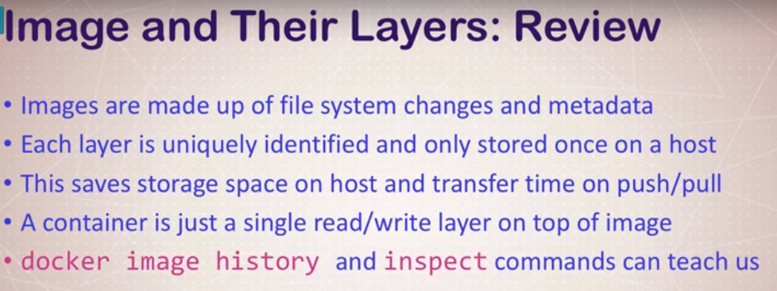

docker image history <image_name> – Shows layers of changes made in image.

docker image inspect <image_name> - returns Jason metadata about the image.

<https://docs.docker.com/storage/storagedriver/> <Container and image>

**Tagging:**

docker image tag nginx imsunarv/nginx

docker image ls

docker image push imsunarv/nginx

docker login

docker image push imsunarv/nginx

docker logout

cat .docker/config.json – Authorization details for our login

**Building Docker file**

docker image build -t customnginx .

